Ellen Hirst  LB North East and Yorkshire  Newcastle upon Tyne  NE98 1ZZ |   Date: 23 June 2025  Our Ref:

Analysis of Murano REIT's eligibility to become a UK REIT
Dear Ellen
You asked us to provide an assessment of whether your proposed Murano REIT structure is eligible to become a UK REIT. We have completed the relevant analysis and, while it passes some of the applicable tests, unfortunately it fails Company Condition D.
This report outlines which REIT tests Murano REIT passed and which it failed, and then provides our recommendations for how it could be restructured to ensure eligibility.
As a summary of Murano REIT's performance against the key REIT tests:
- It satisfies Company Condition A because it is a UK company. It is incorporated in England (Incorporation Registration Number 528996) and is not tax resident anywhere outside the UK.
- It satisfies Company Condition B because it is not an open-ended investment company under s. 236 Financial Services and Markets Act 2000.
- It satisfies Company Condition C because 77.61% of its ordinary shares are held by institutional investors, which is in excess of the statutory 70% required. Details of how Murano REIT meets this requirement are included in Appendix 1C.
- It currently fails Company Condition D since it is a close company, even when institutional investor participators are disregarded.
- It satisfies Company Condition E because it has only one class of ordinary shares, and restricted preference shares that only carry a conditional, currently non-exercisable right to vote and a right to dividends that is permitted.
- It satisfies Company Condition F because none of its debts have any statutorily prohibited features. That is, none of the loans where Murano REIT is the debtor contain terms where:
a) the loan interest depends on the results of its business or the value of its assets;
b) the loan interest exceeds a reasonable commercial return on the principal lent;
c) the total repayment exceeds the principal lent or reasonable market rates.
Going forwards, Murano REIT will ensure any additional debt finance it secures is compatible with the requirements of Company Condition F.
[Practitioner recommendations for restructuring the REIT candidate]
Yours Sincerely,
Smithers Solicitors

Appendix 1C: Institutional investors
Murano REIT meets Company Condition C because 77.61% of its ordinary share capital is held by institutional investors, which is more than the statutory 70% threshold.
The table below records who the institutional investors in Murano REIT are, why we say they fall inside one of the statutory categories of institutional investors, and their total shareholding in Murano REIT.
One of these investors is a limited partnership which needs genuine diversity of ownership to be classed as institutional. We have confirmed that it has this diversity, and would be happy to share our basis for that conclusion if this would assist with your verification that Murano REIT meets Company Condition C
Investor name | Institutional investor category | Total (%)
Abertay Housing Association Ltd | Abertay Housing Association Ltd is a registered social landlord in England.  [Its Scottish Register of Social Landlords Registration Number is 297. ] | 17.0
Pobl Group Ltd | Pobl Group Ltd is a registered social landlord in England.  [Its Welsh Register of Social Landlords Registration Number is J139.] | 11.0
Wrotham Asset Management | Wrotham Asset Management is the trustee/manager [delete as appropriate] of an FCA authorised unit trust.  [We have had sight of an FCA letter approving this unit trust, dated 16/05/2017, their reference number DGT_670517.] | 5.89
Robustco | Robustco has a long-term insurance business.  [It received PRA approval to carry on a long term insurance business in a letter dated 21/09/2011, their reference number INS34272111.] | 5.37
Rubato Futures | Rubato Futures is a pension scheme.  [It provides benefits to the employees of its members on their retirement or ill-health. ] | 6.5
GDR VII | GDR VII is the trustee/manager [delete as appropriate] of an FCA authorised unit trust.  [We have had sight of an FCA letter approving this unit trust, dated 01/10/2013, their reference number DGT_011013.] | 1.67
Alpha Asset Management | Alpha Asset Management is a pension scheme.  [It provides benefits to the employees of its members on their retirement or ill-health. ] | 1.73
KIA | KIA has sovereign immunity from direct UK taxes.  [This is the Kuwaiti sovereign wealth fund, which received a letter confirming its sovereign exemption from direct UK taxes from HMRC's Immunities and Privileges, International Committee on 05/06/2004.] | 6.91
Haus GmbH | Haus GmbH is the trustee/manager [delete as appropriate] of an FCA authorised unit trust.  [We have had sight of an FCA letter approving this unit trust, dated 15/04/2015, their reference number DGT_550415.] | 0.73
Bahrain Mumtalakat Holding Company | Bahrain Mumtalakat Holding Company has sovereign immunity from direct UK taxes.  [This is the Bahrain's sovereign wealth fund, which received a letter confirming its sovereign exemption from direct UK taxes from HMRC's Immunities and Privileges, International Committee on 26/08/2012.] | 3.1
OMII Fund | OMII Fund is the trustee/manager delete as appropriate of a unit trust based in None which is equivalent to an FCA authorised unit trust.  [It is approved by the French AMF and has a certificate of approval dated 03/12/2007.] | 10.13
Draycott Holdings | Draycott Holdings is a limited partnership which is a collective investment scheme.  [Enter notes as appropriate] | 1.03
Murray Edwards College | Murray Edwards College is a charity.  [Its Charity Number is 1137530. ] | 4.72
Ashmolean Museum | Ashmolean Museum is a charity.  [Its Charity Number is 1154932.] | 1.83
Total |  | 77.61

Institutional investor diagrams
These diagrams represent each institutional investor's total ownership of Murano REIT's ordinary share capital.
Abertay Housing Association Ltd
Abertay Housing Association Ltd directly owns 17.00% of Murano REIT.
Pobl Group Ltd
Pobl Group Ltd directly owns 11.00% of Murano REIT.
Wrotham Asset Management
Wrotham Asset Management holds this interest in Murano REIT through the following paths.
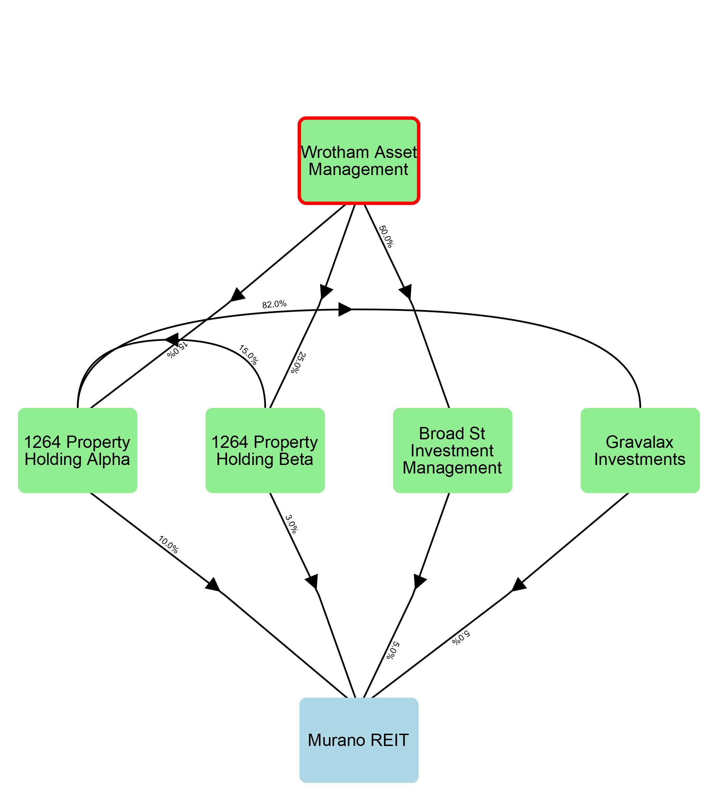
Intermediaries | Path %
Broad St Investment Management | 2.5
1264 Property Holding Alpha | 1.5
1264 Property Holding Beta | 0.75
1264 Property Holding Alpha and Gravalax Investments | 0.61
1264 Property Holding Beta and 1264 Property Holding Alpha | 0.38
1264 Property Holding Beta, 1264 Property Holding Alpha, and Gravalax Investments | 0.15

Robustco
Robustco holds this interest in Murano REIT through the following paths.
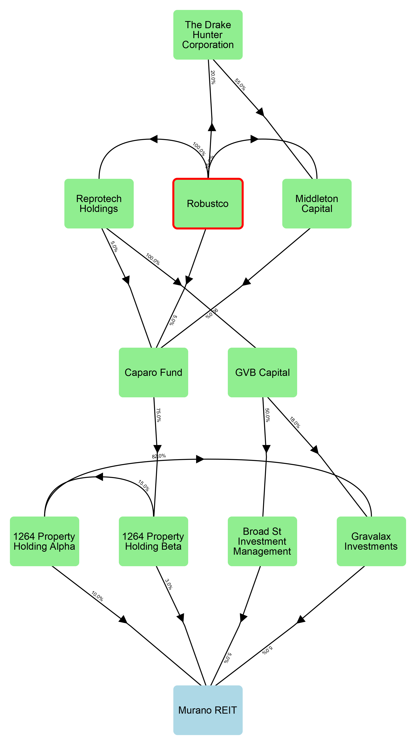
Intermediaries | Path %
Reprotech Holdings, GVB Capital, and Broad St Investment Management | 2.5
Reprotech Holdings, GVB Capital, and Gravalax Investments | 0.9
Middleton Capital , Caparo Fund, and 1264 Property Holding Beta | 0.71
Middleton Capital , Caparo Fund, 1264 Property Holding Beta, and 1264 Property Holding Alpha | 0.35
The Drake Hunter Corporation , Middleton Capital , Caparo Fund, and 1264 Property Holding Beta | 0.22
Middleton Capital , Caparo Fund, 1264 Property Holding Beta, 1264 Property Holding Alpha, and Gravalax Investments | 0.15
Reprotech Holdings, Caparo Fund, and 1264 Property Holding Beta | 0.11
Caparo Fund and 1264 Property Holding Beta | 0.11
The Drake Hunter Corporation , Middleton Capital , Caparo Fund, 1264 Property Holding Beta, and 1264 Property Holding Alpha | 0.11
Reprotech Holdings, Caparo Fund, 1264 Property Holding Beta, and 1264 Property Holding Alpha | 0.06
Caparo Fund, 1264 Property Holding Beta, and 1264 Property Holding Alpha | 0.06
The Drake Hunter Corporation , Middleton Capital , Caparo Fund, 1264 Property Holding Beta, 1264 Property Holding Alpha, and Gravalax Investments | 0.05
Reprotech Holdings, Caparo Fund, 1264 Property Holding Beta, 1264 Property Holding Alpha, and Gravalax Investments | 0.02
Caparo Fund, 1264 Property Holding Beta, 1264 Property Holding Alpha, and Gravalax Investments | 0.02

Rubato Futures
Rubato Futures holds this interest in Murano REIT through the following paths.
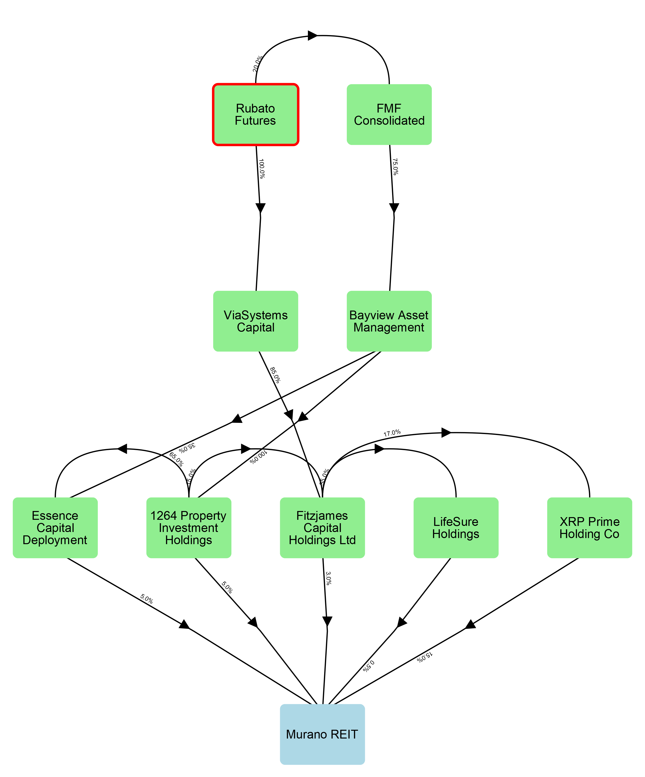
Intermediaries | Path %
ViaSystems Capital and Fitzjames Capital Holdings Ltd | 2.55
ViaSystems Capital , Fitzjames Capital Holdings Ltd, and XRP Prime Holding Co | 2.17
FMF Consolidated, Bayview Asset Management, and 1264 Property Investment Holdings | 0.75
FMF Consolidated, Bayview Asset Management, 1264 Property Investment Holdings, and Essence Capital Deployment | 0.49
FMF Consolidated, Bayview Asset Management, and Essence Capital Deployment | 0.26
ViaSystems Capital , Fitzjames Capital Holdings Ltd, and LifeSure Holdings | 0.15
FMF Consolidated, Bayview Asset Management, 1264 Property Investment Holdings, and Fitzjames Capital Holdings Ltd | 0.07
FMF Consolidated, Bayview Asset Management, 1264 Property Investment Holdings, Fitzjames Capital Holdings Ltd, and XRP Prime Holding Co | 0.06
FMF Consolidated, Bayview Asset Management, 1264 Property Investment Holdings, Fitzjames Capital Holdings Ltd, and LifeSure Holdings | 0.0

GDR VII
GDR VII holds this interest in Murano REIT through the following paths.
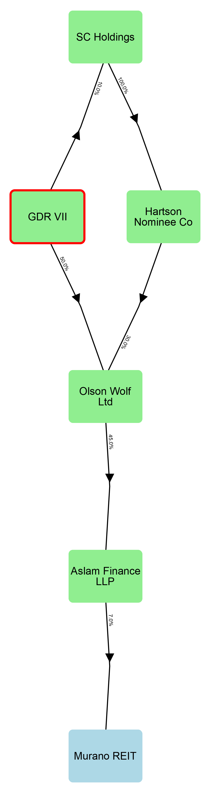
Intermediaries | Path %
Olson Wolf Ltd and Aslam Finance LLP | 1.58
SC Holdings, Hartson Nominee Co , Olson Wolf Ltd, and Aslam Finance LLP | 0.09

Alpha Asset Management
Alpha Asset Management holds this interest in Murano REIT through the following paths.
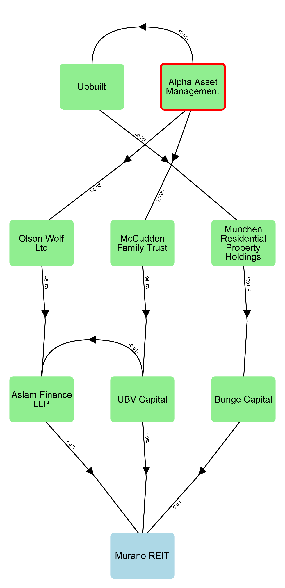
Intermediaries | Path %
Olson Wolf Ltd and Aslam Finance LLP | 0.63
McCudden Family Trust and UBV Capital | 0.56
McCudden Family Trust, UBV Capital , and Aslam Finance LLP | 0.39
Upbuilt, Munchen Residential Property Holdings, and Bunge Capital | 0.14

KIA
KIA holds this interest in Murano REIT through the following paths.
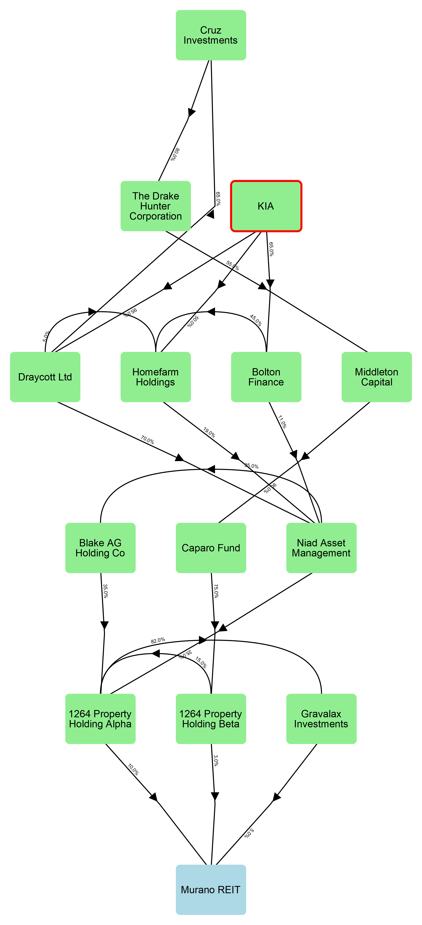
Intermediaries | Path %
Draycott Ltd, Niad Asset Management, and 1264 Property Holding Alpha | 2.33
Draycott Ltd, Niad Asset Management, 1264 Property Holding Alpha, and Gravalax Investments | 0.95
Draycott Ltd, Niad Asset Management, Blake AG Holding Co, and 1264 Property Holding Alpha | 0.81
Draycott Ltd, Cruz Investments, The Drake Hunter Corporation , Middleton Capital , Caparo Fund, and 1264 Property Holding Beta | 0.55
Draycott Ltd, Niad Asset Management, Blake AG Holding Co, 1264 Property Holding Alpha, and Gravalax Investments | 0.33
Homefarm Holdings, Niad Asset Management, and 1264 Property Holding Alpha | 0.33
Draycott Ltd, Cruz Investments, The Drake Hunter Corporation , Middleton Capital , Caparo Fund, 1264 Property Holding Beta, and 1264 Property Holding Alpha | 0.28
Bolton Finance, Niad Asset Management, and 1264 Property Holding Alpha | 0.25
Bolton Finance, Homefarm Holdings, Niad Asset Management, and 1264 Property Holding Alpha | 0.19
Homefarm Holdings, Niad Asset Management, 1264 Property Holding Alpha, and Gravalax Investments | 0.14
Homefarm Holdings, Niad Asset Management, Blake AG Holding Co, and 1264 Property Holding Alpha | 0.12
Draycott Ltd, Cruz Investments, The Drake Hunter Corporation , Middleton Capital , Caparo Fund, 1264 Property Holding Beta, 1264 Property Holding Alpha, and Gravalax Investments | 0.11
Bolton Finance, Niad Asset Management, 1264 Property Holding Alpha, and Gravalax Investments | 0.1
Bolton Finance, Niad Asset Management, Blake AG Holding Co, and 1264 Property Holding Alpha | 0.09
Bolton Finance, Homefarm Holdings, Niad Asset Management, 1264 Property Holding Alpha, and Gravalax Investments | 0.08
Bolton Finance, Homefarm Holdings, Niad Asset Management, Blake AG Holding Co, and 1264 Property Holding Alpha | 0.07
Homefarm Holdings, Niad Asset Management, Blake AG Holding Co, 1264 Property Holding Alpha, and Gravalax Investments | 0.05
Bolton Finance, Niad Asset Management, Blake AG Holding Co, 1264 Property Holding Alpha, and Gravalax Investments | 0.04
Draycott Ltd, Homefarm Holdings, Niad Asset Management, and 1264 Property Holding Alpha | 0.03
Bolton Finance, Homefarm Holdings, Niad Asset Management, Blake AG Holding Co, 1264 Property Holding Alpha, and Gravalax Investments | 0.03
Draycott Ltd, Homefarm Holdings, Niad Asset Management, 1264 Property Holding Alpha, and Gravalax Investments | 0.01
Draycott Ltd, Homefarm Holdings, Niad Asset Management, Blake AG Holding Co, and 1264 Property Holding Alpha | 0.01
Draycott Ltd, Homefarm Holdings, Niad Asset Management, Blake AG Holding Co, 1264 Property Holding Alpha, and Gravalax Investments | 0.0

Haus GmbH
Haus GmbH holds this interest in Murano REIT through the following paths.
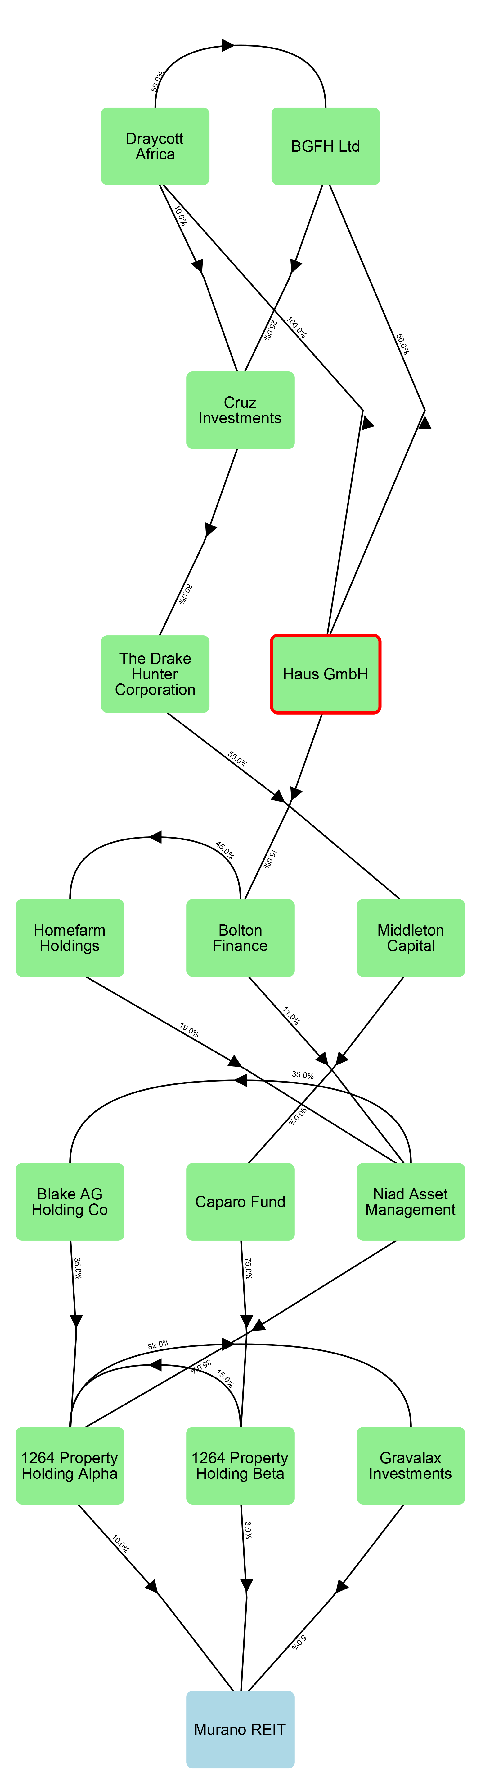
Intermediaries | Path %
BGFH Ltd, Cruz Investments, The Drake Hunter Corporation , Middleton Capital , Caparo Fund, and 1264 Property Holding Beta | 0.11
Draycott Africa, BGFH Ltd, Cruz Investments, The Drake Hunter Corporation , Middleton Capital , Caparo Fund, and 1264 Property Holding Beta | 0.11
Draycott Africa, Cruz Investments, The Drake Hunter Corporation , Middleton Capital , Caparo Fund, and 1264 Property Holding Beta | 0.09
Bolton Finance, Niad Asset Management, and 1264 Property Holding Alpha | 0.06
BGFH Ltd, Cruz Investments, The Drake Hunter Corporation , Middleton Capital , Caparo Fund, 1264 Property Holding Beta, and 1264 Property Holding Alpha | 0.06
Draycott Africa, BGFH Ltd, Cruz Investments, The Drake Hunter Corporation , Middleton Capital , Caparo Fund, 1264 Property Holding Beta, and 1264 Property Holding Alpha | 0.06
Bolton Finance, Homefarm Holdings, Niad Asset Management, and 1264 Property Holding Alpha | 0.04
Draycott Africa, Cruz Investments, The Drake Hunter Corporation , Middleton Capital , Caparo Fund, 1264 Property Holding Beta, and 1264 Property Holding Alpha | 0.04
Bolton Finance, Niad Asset Management, 1264 Property Holding Alpha, and Gravalax Investments | 0.02
BGFH Ltd, Cruz Investments, The Drake Hunter Corporation , Middleton Capital , Caparo Fund, 1264 Property Holding Beta, 1264 Property Holding Alpha, and Gravalax Investments | 0.02
Draycott Africa, BGFH Ltd, Cruz Investments, The Drake Hunter Corporation , Middleton Capital , Caparo Fund, 1264 Property Holding Beta, 1264 Property Holding Alpha, and Gravalax Investments | 0.02
Bolton Finance, Niad Asset Management, Blake AG Holding Co, and 1264 Property Holding Alpha | 0.02
Bolton Finance, Homefarm Holdings, Niad Asset Management, 1264 Property Holding Alpha, and Gravalax Investments | 0.02
Draycott Africa, Cruz Investments, The Drake Hunter Corporation , Middleton Capital , Caparo Fund, 1264 Property Holding Beta, 1264 Property Holding Alpha, and Gravalax Investments | 0.02
Bolton Finance, Homefarm Holdings, Niad Asset Management, Blake AG Holding Co, and 1264 Property Holding Alpha | 0.02
Bolton Finance, Niad Asset Management, Blake AG Holding Co, 1264 Property Holding Alpha, and Gravalax Investments | 0.01
Bolton Finance, Homefarm Holdings, Niad Asset Management, Blake AG Holding Co, 1264 Property Holding Alpha, and Gravalax Investments | 0.01

Bahrain Mumtalakat Holding Company
Bahrain Mumtalakat Holding Company holds this interest in Murano REIT through the following paths.
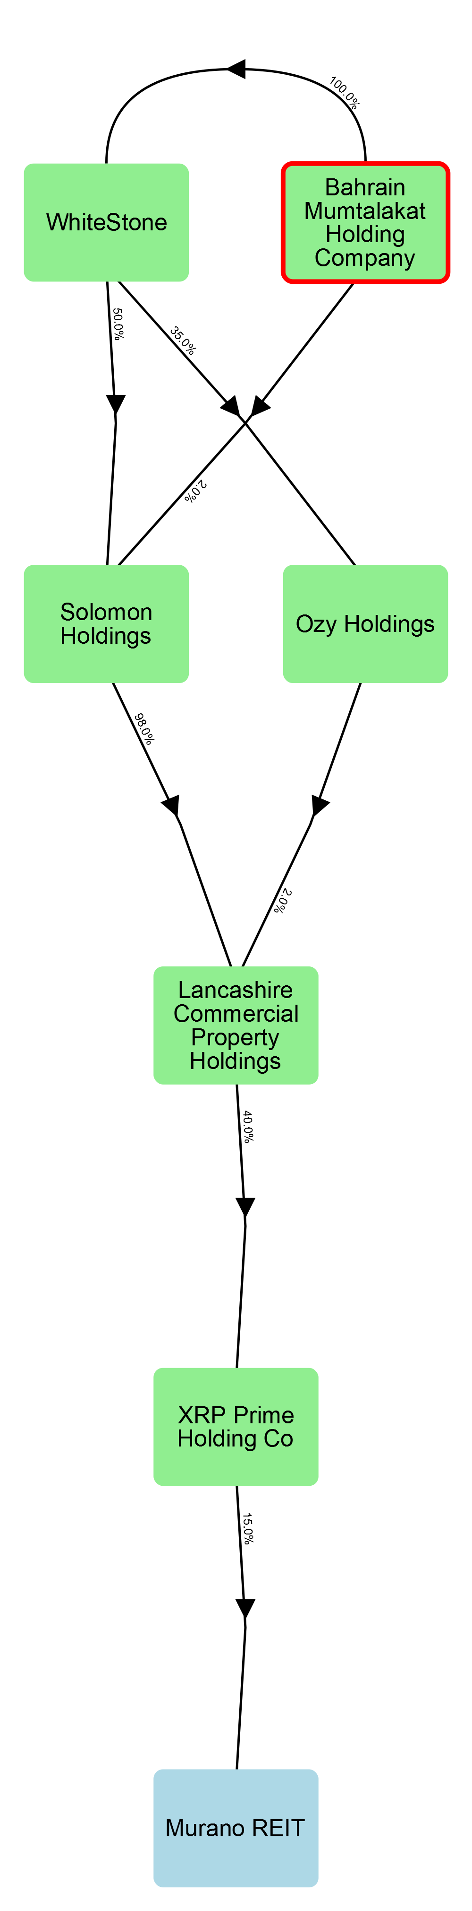
Intermediaries | Path %
WhiteStone, Solomon Holdings, Lancashire Commercial Property Holdings, and XRP Prime Holding Co | 2.94
Solomon Holdings, Lancashire Commercial Property Holdings, and XRP Prime Holding Co | 0.12
WhiteStone, Ozy Holdings, Lancashire Commercial Property Holdings, and XRP Prime Holding Co | 0.04

OMII Fund
OMII Fund holds this interest in Murano REIT through the following paths.
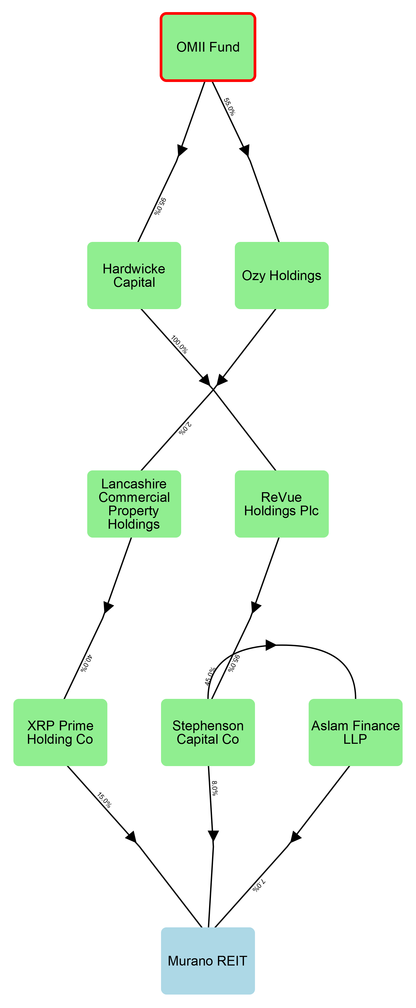
Intermediaries | Path %
Hardwicke Capital, ReVue Holdings Plc, and Stephenson Capital Co | 7.22
Hardwicke Capital, ReVue Holdings Plc, Stephenson Capital Co, and Aslam Finance LLP | 2.84
Ozy Holdings, Lancashire Commercial Property Holdings, and XRP Prime Holding Co | 0.07

Draycott Holdings
Draycott Holdings holds this interest in Murano REIT through the following paths.
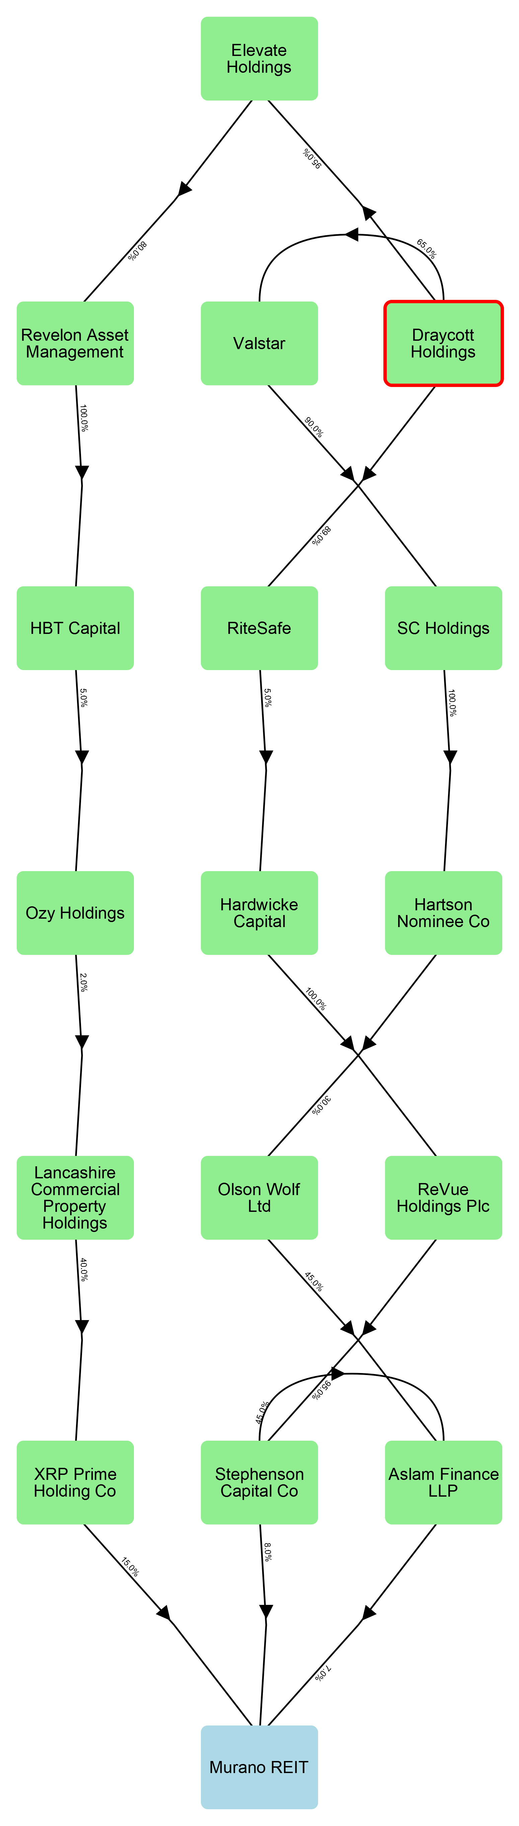
Intermediaries | Path %
Valstar , SC Holdings, Hartson Nominee Co , Olson Wolf Ltd, and Aslam Finance LLP | 0.55
RiteSafe, Hardwicke Capital, ReVue Holdings Plc, and Stephenson Capital Co | 0.34
RiteSafe, Hardwicke Capital, ReVue Holdings Plc, Stephenson Capital Co, and Aslam Finance LLP | 0.13
Elevate Holdings, Revelon Asset Management , HBT Capital , Ozy Holdings, Lancashire Commercial Property Holdings, and XRP Prime Holding Co | 0.0

Murray Edwards College
Murray Edwards College holds this interest in Murano REIT through the following paths.
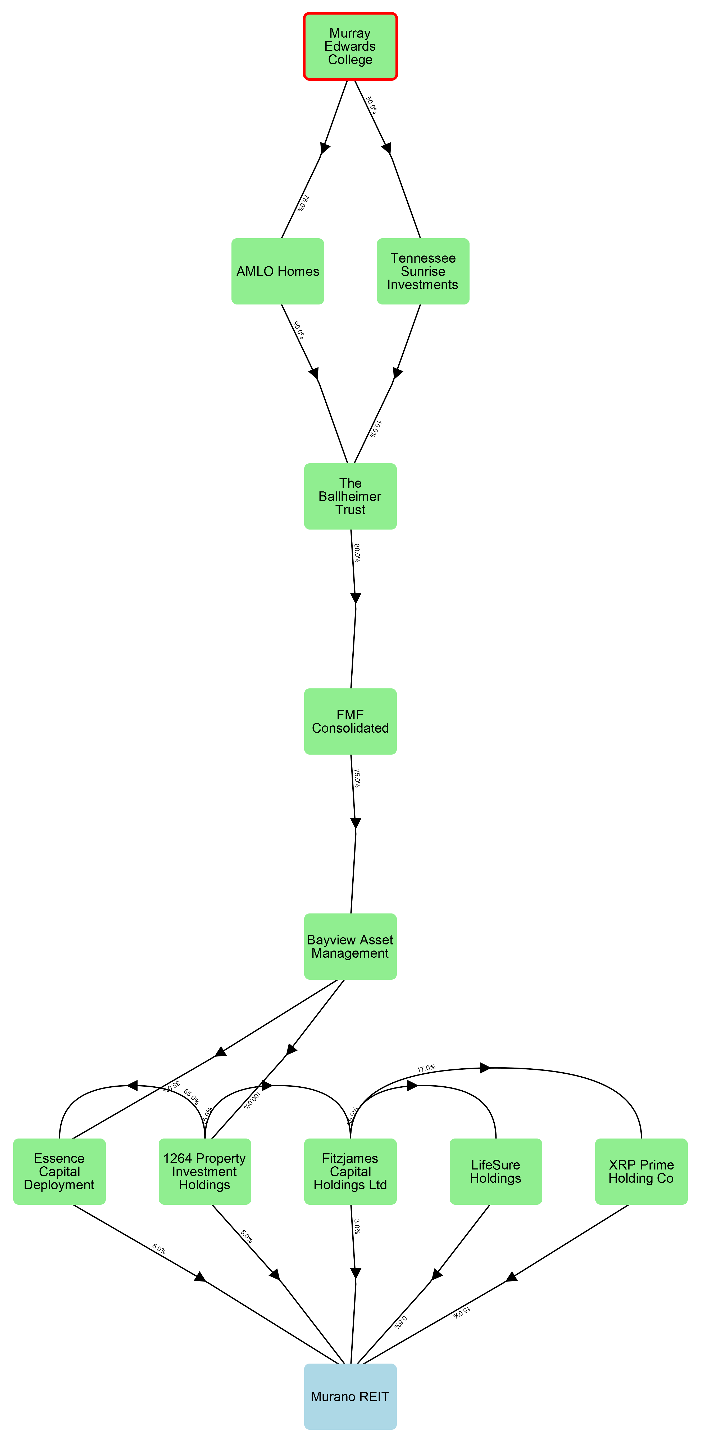
Intermediaries | Path %
AMLO Homes, The Ballheimer Trust, FMF Consolidated, Bayview Asset Management, and 1264 Property Investment Holdings | 2.03
AMLO Homes, The Ballheimer Trust, FMF Consolidated, Bayview Asset Management, 1264 Property Investment Holdings, and Essence Capital Deployment | 1.32
AMLO Homes, The Ballheimer Trust, FMF Consolidated, Bayview Asset Management, and Essence Capital Deployment | 0.71
AMLO Homes, The Ballheimer Trust, FMF Consolidated, Bayview Asset Management, 1264 Property Investment Holdings, and Fitzjames Capital Holdings Ltd | 0.18
AMLO Homes, The Ballheimer Trust, FMF Consolidated, Bayview Asset Management, 1264 Property Investment Holdings, Fitzjames Capital Holdings Ltd, and XRP Prime Holding Co | 0.15
Tennessee Sunrise Investments, The Ballheimer Trust, FMF Consolidated, Bayview Asset Management, and 1264 Property Investment Holdings | 0.15
Tennessee Sunrise Investments, The Ballheimer Trust, FMF Consolidated, Bayview Asset Management, 1264 Property Investment Holdings, and Essence Capital Deployment | 0.1
Tennessee Sunrise Investments, The Ballheimer Trust, FMF Consolidated, Bayview Asset Management, and Essence Capital Deployment | 0.05
Tennessee Sunrise Investments, The Ballheimer Trust, FMF Consolidated, Bayview Asset Management, 1264 Property Investment Holdings, and Fitzjames Capital Holdings Ltd | 0.01
Tennessee Sunrise Investments, The Ballheimer Trust, FMF Consolidated, Bayview Asset Management, 1264 Property Investment Holdings, Fitzjames Capital Holdings Ltd, and XRP Prime Holding Co | 0.01
AMLO Homes, The Ballheimer Trust, FMF Consolidated, Bayview Asset Management, 1264 Property Investment Holdings, Fitzjames Capital Holdings Ltd, and LifeSure Holdings | 0.01
Tennessee Sunrise Investments, The Ballheimer Trust, FMF Consolidated, Bayview Asset Management, 1264 Property Investment Holdings, Fitzjames Capital Holdings Ltd, and LifeSure Holdings | 0.0

Ashmolean Museum
Ashmolean Museum holds this interest in Murano REIT through the following path.
Intermediaries | Path %
Marshall Pace, Hartson Flom Holdings, Solomon Holdings, Lancashire Commercial Property Holdings, and XRP Prime Holding Co | 1.83

Appendix 1D: Closed company analysis

Involved parties
The table below records all parties involved with Murano REIT, which close company tests (if any) they are relevant to, and whether they are also a director or lender. It also identifies who their statutory associates are.
Name (ID) | Participator in tests | Director in tests | Lender | Associates
1264 Property Holding Alpha (2) | Control | - | -
1264 Property Holding Beta (3) | Control | - | -
1264 Property Investment Holdings (7) | Control | - | -
AMLO Homes (66) | - | - | -
Abertay Housing Association Ltd (13) | Both | - | -
Achilleas Holdings (17) | Control | - | -
Alpha Asset Management (45) | - | - | -
Argenta (74) | - | - | -
Ashmolean Museum (58) | Assets | - | -
Aslam Finance LLP (15) | Control | - | -
BFG Capital (26) | Assets | - | -
BGFH Ltd (54) | - | - | -
Bahrain Mumtalakat Holding Company (59) | Assets | - | -
Bayview Asset Management (24) | - | - | -
Blake AG Holding Co (20) | - | - | -
Bolton Finance (46) | - | - | -
Broad St Investment Management (4) | Control | - | -
Bunge Capital (18) | Control | - | -
Caparo Fund (22) | - | - | -
Cruz Investments (47) | - | - | -
Draycott Africa (65) | - | - | -
Draycott Holdings (63) | Assets | - | -
Draycott Ltd (64) | - | - | -
Elevate Holdings (61) | - | - | -
Essence Capital Deployment (6) | Control | - | -
FMF Consolidated (73) | - | - | -
Fearn Asset Management (11) | Control | - | -
Fitzjames Capital Holdings Ltd (8) | Control | - | -
GDR VII (44) | Assets | - | -
GVB Capital (23) | - | - | -
Gravalax Investments (5) | Control | - | -
HBT Capital (50) | - | - | -
Haber Partners (36) | - | - | -
Hardwicke Capital (76) | - | - | -
Hartson Flom Holdings (49) | - | - | -
Hartson Nominee Co (77) | - | - | -
Haus GmbH (55) | - | - | -
Homefarm Holdings (39) | - | - | -
JBL Capital (34) | Assets | - | -
KIA (53) | Assets | - | -
Lancashire Commercial Property Holdings (35) | - | - | -
LifeSure Holdings (9) | Control | - | -
Marshall Pace (67) | - | - | -
McCudden Family Trust (28) | - | - | -
Middleton Capital (31) | - | - | -
Munchen Residential Property Holdings (29) | - | - | -
Murray Edwards College (56) | Assets | - | -
Niad Asset Management (30) | - | - | -
OMII Fund (43) | Assets | - | -
Olson Wolf Ltd (37) | - | - | -
Ozy Holdings (75) | - | - | -
Pobl Group Ltd (19) | Both | - | -
ReVue Holdings Plc (27) | - | - | -
Reprotech Holdings (32) | - | - | -
Revelon Asset Management (69) | - | - | -
RiteSafe (51) | - | - | -
Robustco (40) | - | - | -
Rubato Futures (41) | - | - | -
SC Holdings (52) | - | - | -
Solomon Holdings (42) | - | - | -
Stephenson Capital Co (14) | Control | - | -
Target Holdings (25) | - | - | -
Tate Investment Holdings (12) | Control | - | -
Tennessee Sunrise Investments (57) | - | - | -
The Ballheimer Trust (48) | - | - | -
The Drake Hunter Corporation (72) | - | - | -
UBV Capital (16) | Control | - | -
Upbuilt (38) | - | - | -
Valstar (71) | - | - | -
ViaSystems Capital (33) | - | - | -
WhiteStone (68) | - | - | -
Wrotham Asset Management (21) | Assets | - | -
XRP Prime Holding Co (10) | Control | - | -

Appendix 1D: Control test in detail
In total, there are eighteen statutory 'participators' in Murano REIT for the purposes of the control test. After performing the statutory process of attributing rights, 68.00% of Murano REIT's shares are held by a group of five of these participators, which is more than the 50% threshold for that group to be in control. There are no directors of Murano REIT who are also participators for the purposes of this control test. The attributions made can be reviewed in the section below titled 'Attribution of rights'.

Participators
The table below records who the statutory participators in Murano REIT are, and explains why they are participators for the purposes of the control test.
Participator | Reason for participator status
1264 Property Holding Alpha | Direct ownership
1264 Property Holding Beta | Direct ownership
1264 Property Investment Holdings | Direct ownership
Abertay Housing Association Ltd | Direct ownership
Achilleas Holdings | Direct ownership
Aslam Finance LLP | Direct ownership
Broad St Investment Management | Direct ownership
Bunge Capital | Direct ownership
Essence Capital Deployment | Direct ownership
Fearn Asset Management | Direct ownership
Fitzjames Capital Holdings Ltd | Direct ownership
Gravalax Investments | Direct ownership
LifeSure Holdings | Direct ownership
Pobl Group Ltd | Direct ownership
Stephenson Capital Co | Direct ownership
Tate Investment Holdings | Direct ownership
UBV Capital | Direct ownership
XRP Prime Holding Co | Direct ownership

Directors
There are no statutory participators in Murano REIT who are also directors for the purposes of the control test.

Attribution of rights
Four statutory measures of control were considered to determine if Murano REIT satisfies the control test: share capital, voting rights, rights to income, and rights to assets on winding up.
The statutory process of attributing rights was performed. This process requires rights be attributed between associates with a view to achieving the highest concentration of rights within the smallest group of participators.
The highest concentration of rights was achieved in relation to share capital. The table below records how the share capital in Murano REIT was initially distributed among its statutory participators, and how the share capital was attributed to maximise concentration.
Participator | Initial (%) | Attributions made | Final (%)
1264 Property Holding Alpha | 10.00% | 5.00% received from Gravalax Investments | 15.00%
1264 Property Holding Beta | 3.00% | No attributions | 3.00%
1264 Property Investment Holdings | 5.00% | 5.00% received from Essence Capital Deployment | 10.00%
Abertay Housing Association Ltd | 17.00% | No attributions | 17.00%
Achilleas Holdings | 1.00% | No attributions | 1.00%
Aslam Finance LLP | 7.00% | No attributions | 7.00%
Broad St Investment Management | 5.00% | No attributions | 5.00%
Bunge Capital | 1.00% | No attributions | 1.00%
Essence Capital Deployment | 5.00% | 5.00% transferred to 1264 Property Investment Holdings | 0.00%
Fearn Asset Management | 1.00% | No attributions | 1.00%
Fitzjames Capital Holdings Ltd | 3.00% | No attributions | 3.00%
Gravalax Investments | 5.00% | 5.00% transferred to 1264 Property Holding Alpha | 0.00%
LifeSure Holdings | 0.50% | No attributions | 0.50%
Pobl Group Ltd | 11.00% | No attributions | 11.00%
Stephenson Capital Co | 8.00% | No attributions | 8.00%
Tate Investment Holdings | 1.00% | No attributions | 1.00%
UBV Capital | 1.00% | No attributions | 1.00%
XRP Prime Holding Co | 15.00% | No attributions | 15.00%
Therefore the 5 participators with the greatest proportion of share capital control 68.0%.
The total proportion of share capital controlled by directors who are also participators (*) is 0.0%.

Appendix 1D: Control test with institutional investor exception
Although Murano REIT is a close company under the control test, it can still satisfy Company Condition D if it is only close because it has as a participator an 'Institutional Investor'. The analysis that follows in this section excludes the Institutional Investors who were identified as participators in the preceding section's control test analysis.
Disregarding institutional investors, there are sixteen statutory 'participators' in Murano REIT for the purposes of the control test. After performing the statutory process of attributing rights, 55.00% of Murano REIT's shares are held by a group of five of these participators, which is more than the 50% threshold for that group to be in control. There are no directors of Murano REIT who are also participators for the purposes of this control test. The attributions made can be reviewed in the section below titled 'Attribution of rights'.

Participators
The table below records who the statutory participators in Murano REIT are, and explains why they are participators for the purposes of the control test.The following participators were excluded on the grounds of being institutional investors: Pobl Group Ltd and Abertay Housing Association Ltd
Participator | Reason for participator status
1264 Property Holding Alpha | Direct ownership
1264 Property Holding Beta | Direct ownership
1264 Property Investment Holdings | Direct ownership
Achilleas Holdings | Direct ownership
Aslam Finance LLP | Direct ownership
Broad St Investment Management | Direct ownership
Bunge Capital | Direct ownership
Essence Capital Deployment | Direct ownership
Fearn Asset Management | Direct ownership
Fitzjames Capital Holdings Ltd | Direct ownership
Gravalax Investments | Direct ownership
LifeSure Holdings | Direct ownership
Stephenson Capital Co | Direct ownership
Tate Investment Holdings | Direct ownership
UBV Capital | Direct ownership
XRP Prime Holding Co | Direct ownership

Directors
There are no statutory participators in Murano REIT who are also directors for the purposes of the control test.

Attribution of rights
Four statutory measures of control were considered to determine if Murano REIT satisfies the control test: share capital, voting rights, rights to income, and rights to assets on winding up.
The statutory process of attributing rights was performed. This process requires rights be attributed between associates with a view to achieving the highest concentration of rights within the smallest group of participators.
The highest concentration of rights was achieved in relation to share capital. The table below records how the share capital in Murano REIT was initially distributed among its statutory participators, and how the share capital was attributed to maximise concentration.
Participator | Initial (%) | Attributions made | Final (%)
1264 Property Holding Alpha | 10.00% | 5.00% received from Gravalax Investments | 15.00%
1264 Property Holding Beta | 3.00% | No attributions | 3.00%
1264 Property Investment Holdings | 5.00% | 5.00% received from Essence Capital Deployment | 10.00%
Achilleas Holdings | 1.00% | No attributions | 1.00%
Aslam Finance LLP | 7.00% | No attributions | 7.00%
Broad St Investment Management | 5.00% | No attributions | 5.00%
Bunge Capital | 1.00% | No attributions | 1.00%
Essence Capital Deployment | 5.00% | 5.00% transferred to 1264 Property Investment Holdings | 0.00%
Fearn Asset Management | 1.00% | No attributions | 1.00%
Fitzjames Capital Holdings Ltd | 3.00% | No attributions | 3.00%
Gravalax Investments | 5.00% | 5.00% transferred to 1264 Property Holding Alpha | 0.00%
LifeSure Holdings | 0.50% | No attributions | 0.50%
Stephenson Capital Co | 8.00% | No attributions | 8.00%
Tate Investment Holdings | 1.00% | No attributions | 1.00%
UBV Capital | 1.00% | No attributions | 1.00%
XRP Prime Holding Co | 15.00% | No attributions | 15.00%
Therefore the 5 participators with the greatest proportion of share capital control 55.0%.
The total proportion of share capital controlled by directors who are also participators (*) is 0.0%.

Appendix 1D: Assets test in detail
In total, there are twelve statutory participators in Murano REIT for the purposes of the assets test. After statutory rights attributions, 50.93% of its assets are held by a group of five of these participators, which is above the 50% threshold for that group to be in control. There are no directors of Murano REIT who are also participators for the purposes of this assets test. The attributions made can be reviewed in the section below titled 'Attribution of rights'.

Participators
The table below records who the statutory participators in Murano REIT are, and explains why they are participators for the purposes of the assets test.
Participator | Reason for participator status
Abertay Housing Association Ltd | Direct entitlement
Ashmolean Museum | Indirect entitlement via Marshall Pace, Hartson Flom Holdings, Solomon Holdings, Lancashire Commercial Property Holdings, and XRP Prime Holding Co
BFG Capital | Indirect entitlement via XRP Prime Holding Co
Bahrain Mumtalakat Holding Company | Indirect entitlement via WhiteStone, Ozy Holdings, Lancashire Commercial Property Holdings, and XRP Prime Holding Co
Draycott Holdings | Indirect entitlement via Valstar , SC Holdings, Hartson Nominee Co , Olson Wolf Ltd, and Aslam Finance LLP
GDR VII | Indirect entitlement via SC Holdings, Hartson Nominee Co , Olson Wolf Ltd, and Aslam Finance LLP
JBL Capital | Indirect entitlement via Target Holdings and XRP Prime Holding Co
KIA | Indirect entitlement via Draycott Ltd, Cruz Investments, The Drake Hunter Corporation , Middleton Capital , Caparo Fund, 1264 Property Holding Beta, 1264 Property Holding Alpha, and Gravalax Investments
Murray Edwards College | Indirect entitlement via AMLO Homes, The Ballheimer Trust, FMF Consolidated, Bayview Asset Management, 1264 Property Investment Holdings, Fitzjames Capital Holdings Ltd, and XRP Prime Holding Co
OMII Fund | Indirect entitlement via Hardwicke Capital, ReVue Holdings Plc, Stephenson Capital Co, and Aslam Finance LLP
Pobl Group Ltd | Direct entitlement
Wrotham Asset Management | Indirect entitlement via Broad St Investment Management

Directors
There are no statutory participators in Murano REIT who are also directors for the purposes of the assets test.

Attribution of rights
The table below records how the winding-up rights in Murano REIT were initially distributed among its statutory participators, and how the winding-up rights were attributed to maximise concentration for the purposes of the assets test.
Participator | Initial (%) | Attributions made | Final (%)
Abertay Housing Association Ltd | 17.00% | No attributions | 17.00%
Ashmolean Museum | 1.83% | No attributions | 1.83%
BFG Capital | 3.00% | No attributions | 3.00%
Bahrain Mumtalakat Holding Company | 3.10% | No attributions | 3.10%
Draycott Holdings | 1.03% | No attributions | 1.03%
GDR VII | 1.67% | No attributions | 1.67%
JBL Capital | 0.78% | No attributions | 0.78%
KIA | 6.91% | No attributions | 6.91%
Murray Edwards College | 4.72% | No attributions | 4.72%
OMII Fund | 10.13% | No attributions | 10.13%
Pobl Group Ltd | 11.00% | No attributions | 11.00%
Wrotham Asset Management | 5.89% | No attributions | 5.89%
Therefore the 5 participators with the greatest proportion of winding-up rights control 50.93% (50.93% if the rights of loan creditors are disregarded).
The total proportion of winding-up rights controlled by directors who are also participators (*) is 0.0% (0.0% if the rights of loan creditors are disregarded).

Appendix 1D: Assets test with institutional investor exception
Although Murano REIT is a close company under the assets test, it can still satisfy Company Condition D if it is only close because it has as a participator an 'Institutional Investor'. The analysis that follows in this section excludes the Institutional Investors who were identified as participators in the preceding section's assets test analysis.
Disregarding institutional investors, there are sixteen statutory 'participators' in Murano REIT for the purposes of the control test. After performing the statutory process of attributing rights, 55.00% of Murano REIT's shares are held by a group of five of these participators, which is more than the 50% threshold for that group to be in control. There are no directors of Murano REIT who are also participators for the purposes of this control test. The attributions made can be reviewed in the section below titled 'Attribution of rights'.

Participators
The table below records who the statutory participators in Murano REIT are, and explains why they are participators for the purposes of the control test.The following participators were excluded on the grounds of being institutional investors: Pobl Group Ltd and Abertay Housing Association Ltd
Participator | Reason for participator status
1264 Property Holding Alpha | Direct ownership
1264 Property Holding Beta | Direct ownership
1264 Property Investment Holdings | Direct ownership
Achilleas Holdings | Direct ownership
Aslam Finance LLP | Direct ownership
Broad St Investment Management | Direct ownership
Bunge Capital | Direct ownership
Essence Capital Deployment | Direct ownership
Fearn Asset Management | Direct ownership
Fitzjames Capital Holdings Ltd | Direct ownership
Gravalax Investments | Direct ownership
LifeSure Holdings | Direct ownership
Stephenson Capital Co | Direct ownership
Tate Investment Holdings | Direct ownership
UBV Capital | Direct ownership
XRP Prime Holding Co | Direct ownership

Directors
There are no statutory participators in Murano REIT who are also directors for the purposes of the control test.

Attribution of rights
Four statutory measures of control were considered to determine if Murano REIT satisfies the control test: share capital, voting rights, rights to income, and rights to assets on winding up.
The statutory process of attributing rights was performed. This process requires rights be attributed between associates with a view to achieving the highest concentration of rights within the smallest group of participators.
The highest concentration of rights was achieved in relation to share capital. The table below records how the share capital in Murano REIT was initially distributed among its statutory participators, and how the share capital was attributed to maximise concentration.
Participator | Initial (%) | Attributions made | Final (%)
1264 Property Holding Alpha | 10.00% | 5.00% received from Gravalax Investments | 15.00%
1264 Property Holding Beta | 3.00% | No attributions | 3.00%
1264 Property Investment Holdings | 5.00% | 5.00% received from Essence Capital Deployment | 10.00%
Achilleas Holdings | 1.00% | No attributions | 1.00%
Aslam Finance LLP | 7.00% | No attributions | 7.00%
Broad St Investment Management | 5.00% | No attributions | 5.00%
Bunge Capital | 1.00% | No attributions | 1.00%
Essence Capital Deployment | 5.00% | 5.00% transferred to 1264 Property Investment Holdings | 0.00%
Fearn Asset Management | 1.00% | No attributions | 1.00%
Fitzjames Capital Holdings Ltd | 3.00% | No attributions | 3.00%
Gravalax Investments | 5.00% | 5.00% transferred to 1264 Property Holding Alpha | 0.00%
LifeSure Holdings | 0.50% | No attributions | 0.50%
Stephenson Capital Co | 8.00% | No attributions | 8.00%
Tate Investment Holdings | 1.00% | No attributions | 1.00%
UBV Capital | 1.00% | No attributions | 1.00%
XRP Prime Holding Co | 15.00% | No attributions | 15.00%
Therefore the 5 participators with the greatest proportion of share capital control 55.0%.
The total proportion of share capital controlled by directors who are also participators (*) is 0.0%.

UK Corporation Tax Act 2010, ss.528(1), 521(1); UK Corporation Tax Act 2009, s.14(1).
UK Corporation Tax Act 2010, s.528(2); UK Financial Services and Markets Act 2000, s.236.
UK Corporation Tax Act 2010, s.528(3)(b).
UK Corporation Tax Act 2010, ss.528(6)-(7), 160, 1115, 1119.
UK Corporation Tax Act 2010, ss.528(8)-(9).
UK Corporation Tax Act 2010 s. 528(3)(b).
UK Corporation Tax Act 2010, s.528(3)(b).
UK Corporation Tax Act 2010, s.528(4A)(g)(i).
UK Corporation Tax Act 2010, s.528(4A)(g)(i).
UK Corporation Tax Act 2010, s.528(3)(b).
UK Corporation Tax Act 2010, s.528(4A)(e)(i); UK Financial Services and Markets Act (Regulated Activities) Order 2001, SI 2001/544 Pt II Sch 1.
UK Corporation Tac Act 2010, s.528(4A)(d); UK Finance Act 2004, s.150(1).
UK Corporation Tax Act 2010, s.528(3)(b).
UK Corporation Tac Act 2010, s.528(4A)(d); UK Finance Act 2004, s.150(1).
UK Corporation Tax Act 2010, s.528(4A)(h).
UK Corporation Tax Act 2010, s.528(3)(b).
UK Corporation Tax Act 2010, s.528(4A)(h).
UK Corporation Tax Act 2010, s.528(4A)(a)(ii).
UK Corporation Tax Act 2010, s.528(4A)(c); UK Financial Services and Markets Act s.235.
UK Corporation Tax Act 2010, s.528(4A)(f).
UK Corporation Tax Act 2010, s.528(4A)(f).
UK Corporation Tax Act 2010, s.452.
UK Corporation Tax Act 2010, s.453.
UK Corporation Tax Act 2010, s.448.
UK Corporation Tax Act 2010, s.454.
UK Corporation Tax Act 2010, s.454.
UK Corporation Tax Act 2010, s.454.
S 528(4)(b) UK Corporation Tax Act 2010; S 528(4A) UK Corporation Tax Act 2010
UK Corporation Tax Act 2010, s.454.
UK Corporation Tax Act 2010, s.454.
UK Corporation Tax Act 2010, s.454.
UK Corporation Tax Act 2010, s.454.
UK Corporation Tax Act 2010, s.454.
S 528(4)(b) UK Corporation Tax Act 2010; S 528(4A) UK Corporation Tax Act 2010
UK Corporation Tax Act 2010, s.454.
UK Corporation Tax Act 2010, s.454.
UK Corporation Tax Act 2010, s.454.

